# Group Assignment 2 - Group Lab Activity 2

TNE10006/TNE60006 S2 2022

**Assignment Weight:**   
7.5%

**Assignment Points:**   
50

**Submission Due Date:**

Before Week 12 Lab Session

**Reference Material:**

* Sample Final Practical Assessment (available in Canvas Lab Sessions page, Week 11 tab)

**Instructions:**

1. Form a group of 3-4 people amongst the students present in the lab session
2. Your group discussion time will be in the last 60 minutes of the lab session in Collaborate Ultra, Breakout groups.
3. Discuss and answer the questions in Group Assignment 3 in your breakout group.
4. Organise for your group to meet again to complete all the questions.
5. Each group will submit one completed Group Assignment 3
6. Submit Group Assignment 3, in the Canvas shell, under the Group Lab Activity 3
7. Late penalties will apply for submission after the due date.

**Group Assignment 3 Questions:**

* Section 1: Sample Final Practical Assessment Configuration (30 marks)
* Section 2: Sample Final Practical Assessment Verification and Troubleshooting (20 marks)

**Group Assignment 3:**

|  |  |
| --- | --- |
| **Group Members** | |
| **Name** | **Student Id:** |
| **Trung Kien Nguyen** | **104053642** |

**Section 1: Sample Final Practical Assessment Configuration   
(30 marks)**

Refer to the Sample Final Practical Assessment.

Q1. List the configuration commands required to complete **Task 1: Configure Device Names and MOTD**. For each command, specify the device(s) and operation mode.(1 mark)

*(Router)*

Router>en

Router#conf t

Router(config)#hostname Nairobi

Nairobi(config)#banner motd + ********

** Trung Kien Nguyen Student ID 104053642 **

** This is Group Lab Activity 2 of TNE10006 **

******** +

Nairobi(config)exit

*(Switch 3)*

Switch>en

Switch#conf t

Switch(config)#hostname Tokyo

Tokyo(config)#banner motd + ********

** Trung Kien Nguyen Student ID 104053642 **

** This is Group Lab Activity 2 of TNE10006 **

******** +

Tokyo(config)exit

*(Switch 4)*

Switch>en

Switch#conf t

Switch(config)#hostname Lisbon

Lisbon(config)#banner motd + ********

** Trung Kien Nguyen Student ID 104053642 **

** This is Group Lab Activity 2 of TNE10006 **

******** +

Lisbon(config)exit

Q2. List the configuration commands required to complete **Task 2: Configure VLANs and VLAN membership**. For each command, specify the device(s) and operation mode. (4 marks)

*(Switch 3 - Tokyo)*

Tokyo#conf t

Tokyo(config)#vlan 15

Tokyo(config-vlan)#name Centralbank

Tokyo(config-vlan)#vlan 50

Tokyo(config-vlan)#name Royalmint

Tokyo(config-vlan)#vlan 150

Tokyo(config-vlan)#name Management

Tokyo(config-vlan)#exit

Tokyo(config)#int vlan 15

Tokyo(config-if)#no shut

Tokyo(config-if)#int vlan 50

Tokyo(config-if)#no shut

Tokyo(config-if)#int vlan 150

Tokyo(config-if)#no shut

Tokyo(config-if)#end

*(Switch 4 – Lisbon)*

Lisbon#conf t

Lisbon(config)#vlan 15

Lisbon(config-vlan)#name Centralbank

Lisbon(config-vlan)#vlan 50

Lisbon(config-vlan)#name Royalmint

Lisbon(config-vlan)#vlan 150

Lisbon(config-vlan)#name Management

Lisbon(config-vlan)#exit

Lisbon(config)#int vlan 15

Lisbon(config-if)#no shut

Lisbon(config-if)#int vlan 50

Lisbon(config-if)#no shut

Lisbon(config-if)#int vlan 150

Lisbon(config-if)#no shut

Lisbon(config-if)#exit

Lisbon(config)#int range g1/0/1-24

Lisbon(config-if-range)#shutdown

Lisbon(config-if-range)#exit

Lisbon(config)#int range g1/1/1-4

Lisbon(config-if-range)#shutdown

Lisbon(config-if-range)#exit

Lisbon(config)#int range g1/0/1-3

Lisbon(config-if-range)#no shut

Lisbon(config-if-range)#description Centralbank VLAN

Lisbon(config-if-range)#switchport mode access

Lisbon(config-if-range)#switchport access vlan 15

Lisbon(config-if-range)#exit

Lisbon(config)#int range g1/0/11-13

Lisbon(config-if-range)#no shut

Lisbon(config-if-range)#description Royalmint VLAN

Lisbon(config-if-range)#switchport mode access

Lisbon(config-if-range)#switchport access vlan 50

Lisbon(config-if-range)#end

Q3. List the configuration commands required to complete **Task 3: Configure Router-on-a-Stick**. For each command, specify the device(s) and operation mode. (6 marks)

*(Router – Nairobi)*

Nairobi#conf t

Nairobi(config)#int g0/0/1

Nairobi(config-if)#no shut

Nairobi(config-if)#exit

Nairobi(config)#int lo0

Nairobi(config-if)#description Loopback test interface

Nairobi(config-if)#ip address 53.15.30.33 255.255.255.248

Nairobi(config-if)#exit

Nairobi(config)#int g0/0/1.15

Nairobi(config-if)#description Connection to Centralbank VLAN

Nairobi(config-if)#encapsulation dot1Q 15

Nairobi(config-if)#ip address 213.17.144.254 255.255.255.128

Nairobi(config-if)#exit

Nairobi(config)#int g0/0/1.50

Nairobi(config-if)#description Connection to Royalmint VLAN

Nairobi(config-if)#encapsulation dot1Q 50

Nairobi(config-if)#ip address 165.45.191.254 255.255.224.0

Nairobi(config-if)#exit

Nairobi(config)#int g0/0/1.150

Nairobi(config-if)#description Connection to Management VLAN

Nairobi(config-if)#encapsulation dot1Q 150

Nairobi(config-if)#ip address 55.252.16.254 255.255.255.240

Nairobi(config-if)#end

*(Switch 3 - Tokyo)*

Tokyo#conf t

Tokyo(config)#int range g1/0/5-6

Tokyo(config-if-range)#no shut

Tokyo(config-if-range)#switchport mode trunk

Tokyo(config-if-range)#exit

Tokyo(config)#int g1/0/11

Tokyo(config-if)#no shut

Tokyo(config-if)#switchport mode trunk

Tokyo(config-if)#exit

Tokyo(config)#ip default-gateway 55.252.16.254

Tokyo(config)#end

*(Switch 4 – Lisbon)*

Lisbon#conf t

Lisbon(config)#int range g1/0/5-6

Lisbon(config-if-range)#no shut

Lisbon(config-if-range)#switchport mode trunk

Lisbon(config-if-range)#exit

Lisbon(config)#ip default-gateway 55.252.16.254

Lisbon(config)#end

Q4. List the configuration commands required to complete **Task 4: Configure Switch Management**. For each command, specify the device(s) and operation mode. (6 marks)

*(Switch 3 – Tokyo)*

Tokyo#conf t

Tokyo(config)#int vlan 150

Tokyo(config-if)#ip address 55.252.16.253 255.255.255.240

Tokyo(config-if)#exit

*(Switch 4 – Lisbon)*

Lisbon#conf t

Lisbon(config)#int vlan 150

Lisbon(config-if)#ip address 55.252.16.252 255.255.255.240

Lisbon(config-if)#exit

Lisbon(config)#ip domain-name ccna.lab

Lisbon(config)#cypto key generate rsa general-key mod 1024

Lisbon(config)#username cisco privilege 15 secret cisco

Lisbon(config)#line vty 0 15

Lisbon(config-line)#transport input ssh

Lisbon(config-line)#login local

Lisbon(config-line)#end

Q5. List the configuration commands required to complete **Task 5: Fine-tune STP**. For each command, specify the device(s) and operation mode. (4 marks)

*(Switch 3 – Tokyo)*

Tokyo#conf t

Tokyo(config)#spanning-tree vlan 50 root primary

Tokyo(config)#end

*(Switch 4 – Lisbon)*

Lisbon#conf t

Lisbon(config)#spanning-tree vlan 15 root primary

Lisbon(config)#int range g1/0/1-3

Lisbon(config-if-range)#spanning-tree portfast

Lisbon(config)#int range g1/0/11-13

Lisbon(config-if-range)#spanning-tree portfast

Lisbon(config-if-range)#end

Q6. List the configuration commands required to complete **Task 6: Configure Port-Security.** For each command, specify the device(s) and operation mode. (4 marks)

*(Switch 4 – Lisbon)*

Lisbon#conf t

Lisbon(config)#int g1/0/3

Lisbon(config-if)#switchport port-security

Lisbon(config-if)#switchport port-security violation protect

Lisbon(config-if)#switchport port-security mac-address sticky

Lisbon(config-if)#switchport port-security maximum 2

Q7. List the configuration commands required to complete **Task 7: Configure EtherChannel**. For each command, specify the device(s) and operation mode. (4 marks)

*(Switch 3 – Tokyo)*

Tokyo#conf t

Tokyo(config)#int range g1/0/5-6

Tokyo(config-if-range)#no shut

Tokyo(config-if-range)#channel-group 1 mode active

Tokyo(config-if-range)#exit

Tokyo(config)#int port-channel 1

Tokyo(config-if)#switchport mode trunk

Tokyo(config-if)#switchport trunk native vlan 150

Tokyo(config-if)#end

*(Switch 4 - Lisbon)*

Lisbon#conf t

Lisbon(config)#int range g1/0/5-6

Lisbon(config-if-range)#no shut

Lisbon(config-if-range)#channel-group 1 mode active

Lisbon(config-if-range)#exit

Lisbon(config)#int port-channel 1

Lisbon(config-if)#switchport mode trunk

Lisbon(config-if)#switchport trunk native vlan 150

Lisbon(config-if)#end

Q8. List the configuration commands required to complete **Task 8: Additional Settings.** For each command, specify the device(s) and operation mode. (1 mark)

*(For descriptions configuring on interfaces, I have mentioned above)*

*Configure synchronous logging:*

*(Switch 3 – Tokyo)*

Tokyo#conf t

Tokyo(config)#line con 0

Tokyo(config-line)#logging synchronous

Tokyo(config-line)#end

*(Switch 4 – Lisbon)*

Lisbon#conf t

Lisbon(config)#line con 0

Lisbon(config-line)#logging synchronous

Lisbon(config-line)#end

**Section 2: Sample Final Practical Assessment Validation and Troubleshooting   
(20 marks)**

Refer to the Sample Final Practical Assessment.

Q1. Answer the following questions regarding validating and troubleshooting **VLANs and VLAN membership**

* + 1. What command(s) can be used on **Tokyo** to validate VLANs and VLAN membership configuration? For each command, describe the expected output. (2 marks)

Tokyo#sh vlan br

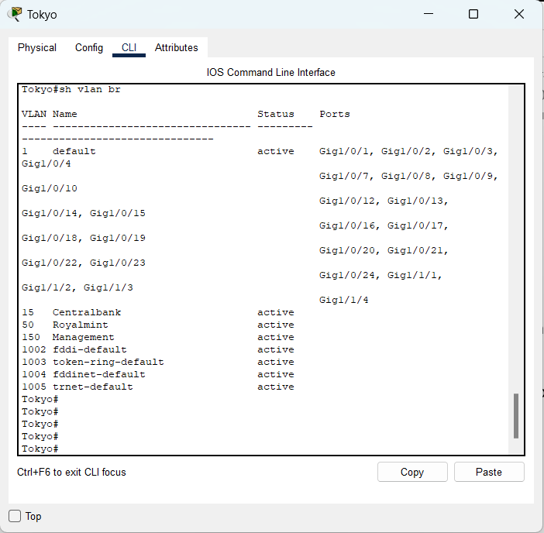

*The ouput: All ports, except g1/0/5 and g1/0/6 (trunking), are assigned to the default VLAN (VLAN 1)*

* + 1. What command(s) can be use on **Lisbon** to validate VLANs and VLAN membership configuration? For each command, describe the expected output. (2 marks)

Lisbon#sh vlan br

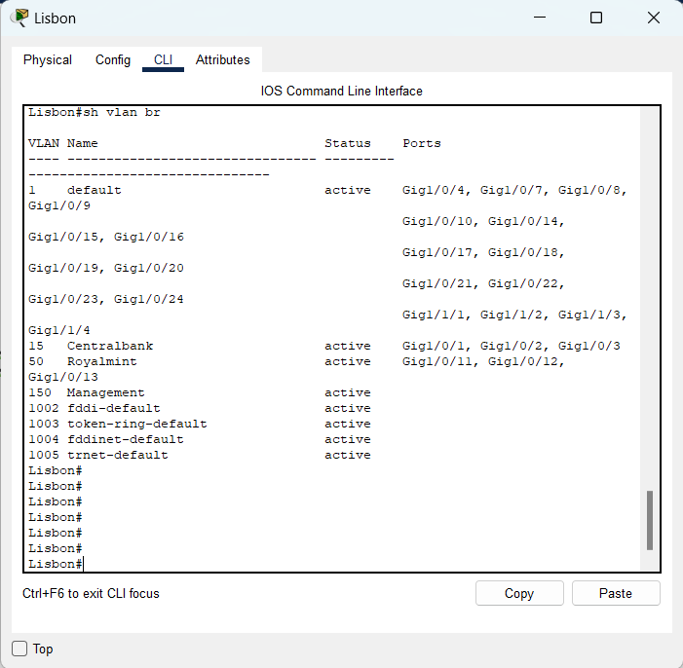

*The ouput: Ports g1/0/1, g1/0/2 and g1/0/3 are assigned to the Centralbank VLAN (VLAN 15), ports g1/0/11, g1/0/12 and g1/0/13 are assigned to the Royalmint VLAN (VLAN 50)*

*All other ports, except g1/0/5 and g1/0/6 (trunking), are assigned to the default VLAN (VLAN 1)*

* + 1. What command(s) can be use on **Lisbon** to validate that all unused ports have been disabled? For each command, describe the expected output. (1 marks)

Lisbon#sh ip int br

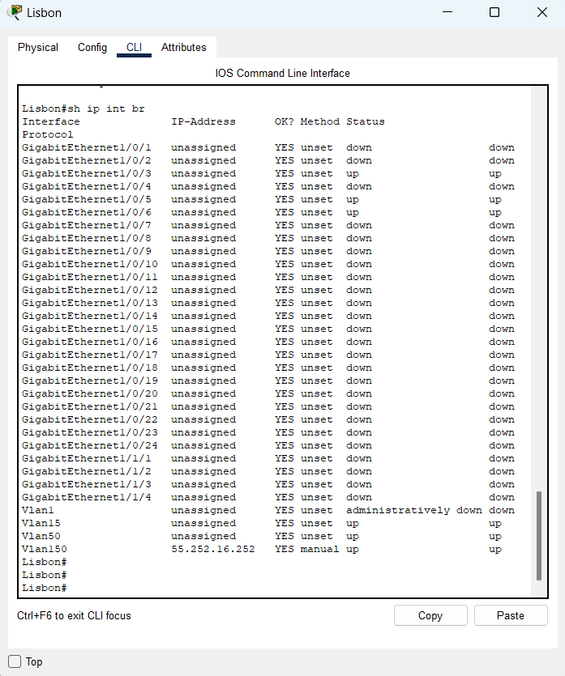

*The ouput: All ports, except g1/0/5, g1/0/6 (trunking) and g1/0/3 (connecting to the PC), is disabled*

Q2. Answer the following question regarding validating and troubleshooting **Router-on-a-Stick**

* + 1. What command(s) can be used on **Nairobi** to validate Router-on-a-Stick configuration? List at least 2. For each command, describe the expected output. (4 marks)

(1) Nairobi#sh ip route

*The output: Four networks are in the Nairobi’s routing table: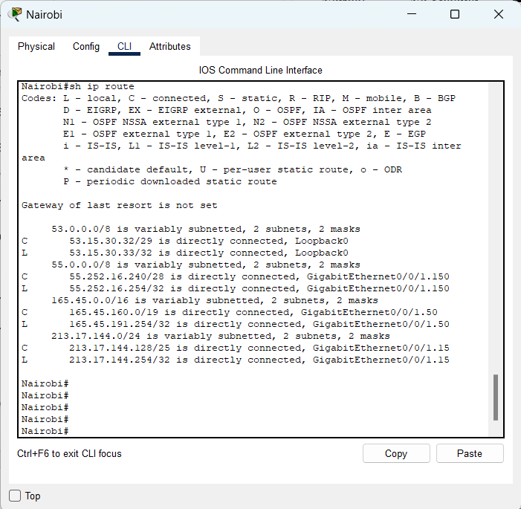*

(2) Nairobi#sh ip int br

*The output: g0/0/0 is down while g0/0/1 is up, as well as 3 sub-interfaces (3 VLANs respectively) and a loopback (0) interface: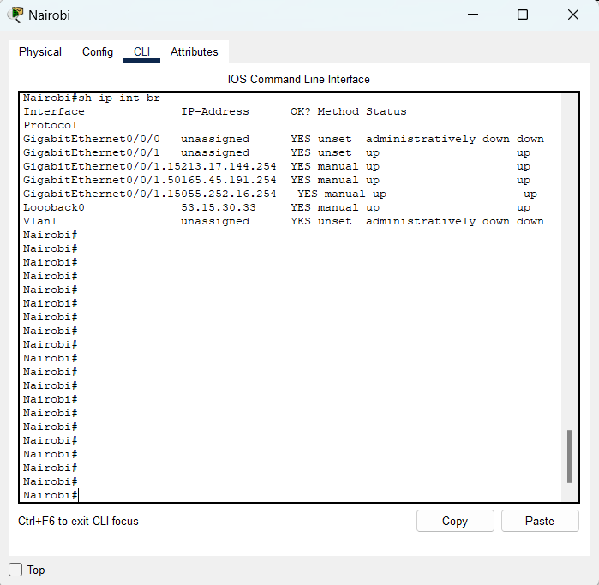*

(3) Nairobi#sh int

*The output: Detailed information about all interfaces on Nairobi:*

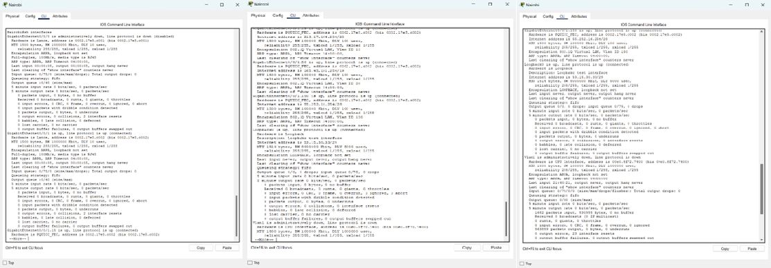

* + 1. What command(s) can be used on **Tokyo** to validate Router-on-a-Stick configuration? For each command, describe the expected output. (1 mark)

(1) Tokyo#sh ip route

*The output: The default-gateway is shown up*

(2) Tokyo#sh int trunk

*The ouput: Trunk interfaces:*

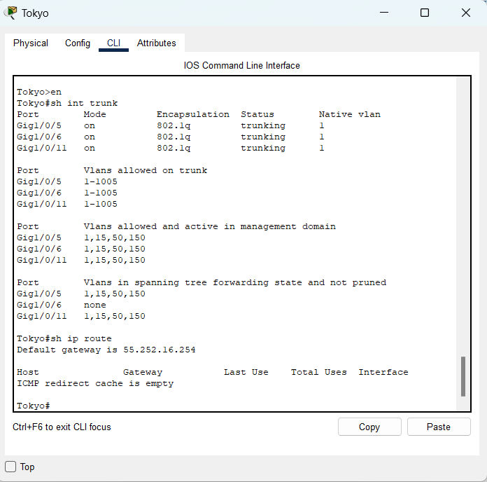

* + 1. Troubleshooting Scenario: The routing table on **Nairobi** is not displaying all the correct connected (C) routes and their exit interfaces.

What are the possible configuration issues? List at least 3 possible issues. (3 marks)

*The possible issues can be: Interface shutdown, wrong ip address for sub-interfaces or clashing ip addresses of interfaces*

Q3. Answer the following questions regarding validating and troubleshooting **Switch Management**

* + 1. What command(s) can be used on **Tokyo** to validate that the Management IP has been correctly configured? For each command, describe the expected output. (1 mark)

Tokyo#sh ip int br



*The output is a table including IP address and Status of all interfaces, and more significantly is of the Management VLAN (VLAN 150).*

* + 1. What command(s) can be used on **Tokyo** to test SSH access to **Lisbon**? (1 mark)

Tokyo#ssh -l cisco 55.252.16.252

(Password: cisco)

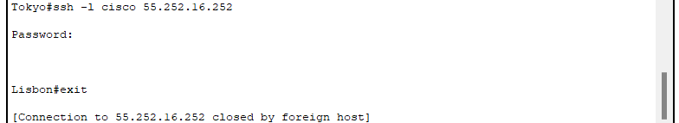

* + 1. Troubleshooting Scenario: **Tokyo** and **Lisbon** can ping each other. **Tokyo** can ping all IP addresses configured on **Nairobi**. However, **Lisbon** can only ping the IP address configured on **Nairobi’s** Management sub-interface; it cannot ping any other router IP.

What is the most likely configuration issue? (1 mark)

*The most likely issue is the default gateway has been configured wrongly.*

Q4. Answer the following questions regarding validating and troubleshooting **STP, Port-Security and EtherChannel**

* + 1. Using the ***show spanning-tree*** command, how do we validate that **Tokyo** has been correctly configured as the root bridge for the Royalmint VLAN? (1 mark)

*After using that command, in the VLAN 50 (Royalmint) information, there should be: “*This bridge is the root”:

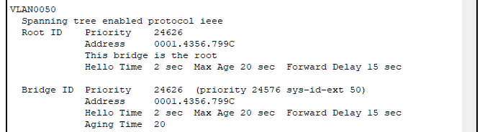

* + 1. What command can be used on **Lisbon** to validate the current Port-Security status of interface Gi1/0/3? (1 mark)

Lisbon#sh port-security int g1/0/3

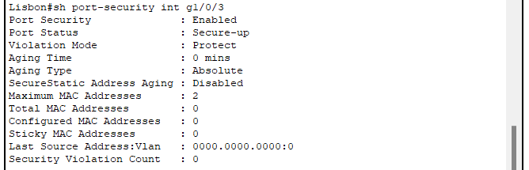

* + 1. If the Port-Channel between **Tokyo** and **Lisbon** has been correctly configured and is fully operational; what should be the status flag(s) next to the Port-Channel interface on the ***show etherchannel summary*** output? (1 mark)

*It is P (in port-channel)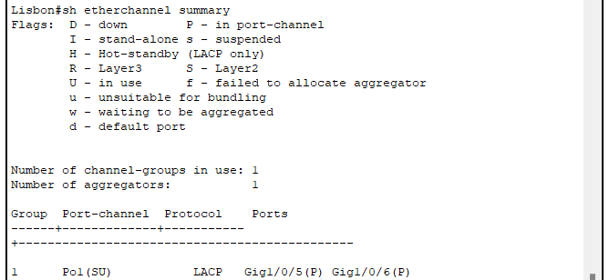*

* + 1. If the Port-Channel between **Tokyo** and **Lisbon** has been correctly configured and is fully operational; what should be the status flag(s) next to the member interfaces on the ***show etherchannel summary*** output? (1 mark)

*They are S (Layer2) and U (in use)*